(Automobile) During the next two months, ASN automobile manufacturer must meet (on time) the following demands for trucks and cars: month 1, 400 trucks and 800 cars; month 2, 300 trucks and 300 cars. During each month at most 1000 vehicles can be produced. Each truck uses two tons of steel, and each car uses one ton of steel. During month 1, steel costs $700 per ton; during month 2, steel is projected to cost $800 per ton. At most 2500 tons of steel can be purchased each month. (Steel can be used only during the month in which it is purchased.) At the beginning of month 1, 100 trucks and 200 cars are in the inventory. At the end of each month, a holding cost of $200 per vehicle is assessed. Each car gets 35 miles per gallon (mpg), and each truck gets 15 mpg. During each month, the vehicles produced by the ASN automobiles must average at least 23 mpg. Determine how to meet the demand and mileage requirements at minimum total cost.

**Discussion: -**

It is similar to the earlier solved aggregate planning problems, only difference is we have two types of vehicles which needs to be produced in two different months. If you can create two indexes, one for vehicle type and one for months and place the inputs in matrix form it is easy to solve this problem.

You can refer to Multiperiod planning problems for understanding the end inventory concept. We will be using similar concept in solving this problem. In this problem, instead of one product ASN automobiles in producing two types of products (trucks & cars).

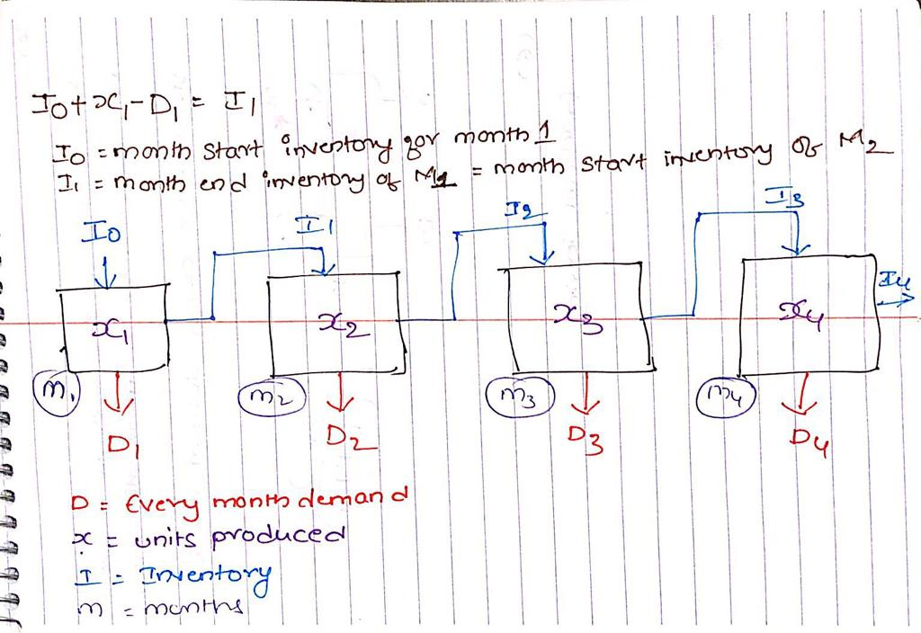

Our objective is to minimize the cost, in order to calculate the same we need the number of the vehicles produced in each month. So this will be our decision variable.

**Mathematical Model: -**

*Parameters (Inputs):*

$$i ϵ 1,2 \left( i: Index for type of vehicles;trucks, cars\right)$$

$$j ϵ 1,2 \left( i: Index for months\right)$$

$$D_{ij} :Demand for vehicle i in month j$$

$$P :Maximum production in each month;1000 units$$

$$S :Maximum steel that can be purchased in a month;2500 tons$$

$$C_{j} :Cost to purchase one ton steel in month j$$

$$M :Avarage mpg expected in each month;23 mpg$$

$$S_{i} :Steel used in tons to produce each unit of vehicle i$$

$$M_{i} :mpg from each vehicle i$$

$$H :Holding cost for each vehicle ;\$200$$

$$I_{ij} :Ending Inventory of vehicle i in month j$$

$$I_{10} :Starting inventory of trucks;100$$

$$I_{20} :Starting inventory of cars;200$$

*Decision Variables:*

$$x_{ij} :Vehicle i produced in month j$$

*Calculated Variables:*

$$I_{ij}= I_{i(j-1)}+x_{ij}-D_{ij} for iϵ\left\{1,2\right\} \& jϵ\left\{1,2\right\} Ending inventory of vehicle i in month j$$

$$H_{j}=\left( \sum_{i=1}^{2}{I_{ij}}\right)*H for jϵ\left\{1,2\right\} Holding cost in month j$$

$$Q_{j}=\left( \sum_{i=1}^{2}{x_{ij}}*S_{i}\right)*C_{j} for jϵ\left\{1,2\right\} Production cost in month j$$

*Objective:*

$$Minimize total cost=\sum_{j=1}^{2}{(H_{j}+Q_{j})}$$

*Constraints:*

$$x_{ij}≥0; \left(1\right) Non Negative constraint$$

$$I_{ij}≥0; \left(2\right) Ending Inventory constraint$$

$$\sum_{i=1}^{2}{{(x}_{ij}}*M_{i}) ≥(\sum_{i=1}^{2}{x_{ij}})*M ; for jϵ\left\{1,2\right\} \left(3\right) Average mpg constraint$$

$$\sum_{i=1}^{2}{x_{ij}}≤P ; for jϵ\left\{1,2\right\} \left(4\right) Production constraint$$

$$\sum_{i=1}^{2}{{(x}_{ij}*S_{i})}≤S ; for jϵ\left\{1,2\right\} \left(5\right) Steel purchase constraint$$

As we need to meet the demand our solution should make sure that ending inventory is always greater than or equal to zero. During each month, the vehicles produced by the ASN automobiles must average at least 23 mpg, so we have written a Avg mpg constraint. On top of this ASN automobiles have limits to produce the vehicles and purchase raw material (steel) for their production. These constraints are listed above.

*Excel Implementation:* Please find the attached spreadsheet for solution.

 